SALES PAGE

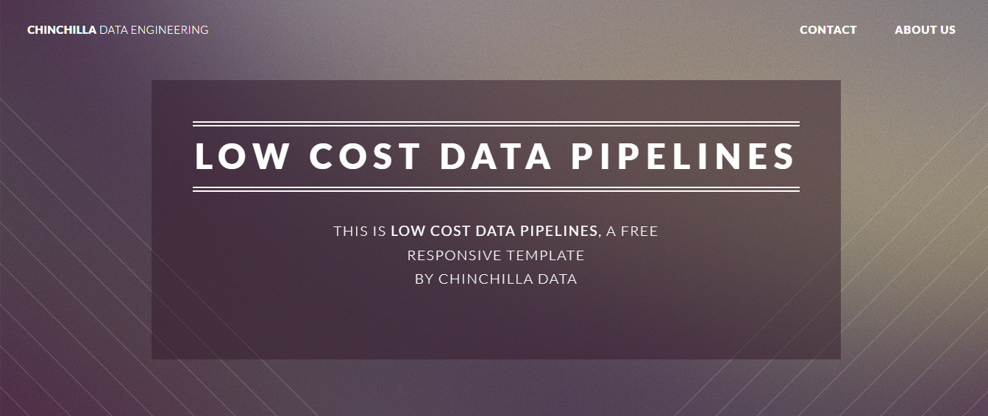

Data pipelines can revolutionize the way your business does analytics, giving you access to more data quickly... ***and we can help you achieve that goal!***

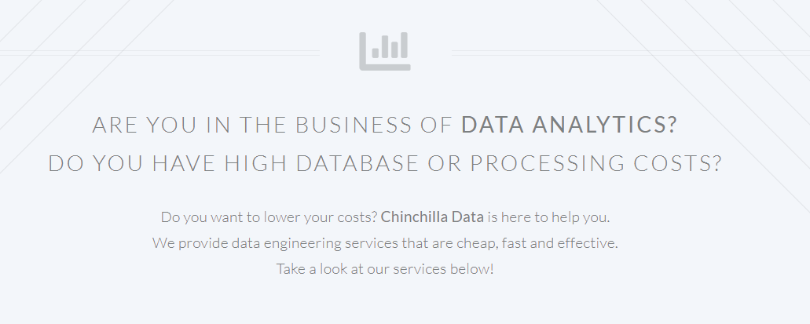

As a mid-size business, you know data is critical to understand how your company is performing. But leveraging that data is tough.

***That’s why we have created a data pipeline service just for you!*** We’ll help build, maintain and optimize catered pipelines to fit the unique needs and objectives of your business.

*And that's not all...*

We won’t leave you in the lurch when we’re done – our team will provide ongoing support as needed so that nothing breaks and changes with the times. Let us guide you on your data-driven journey!

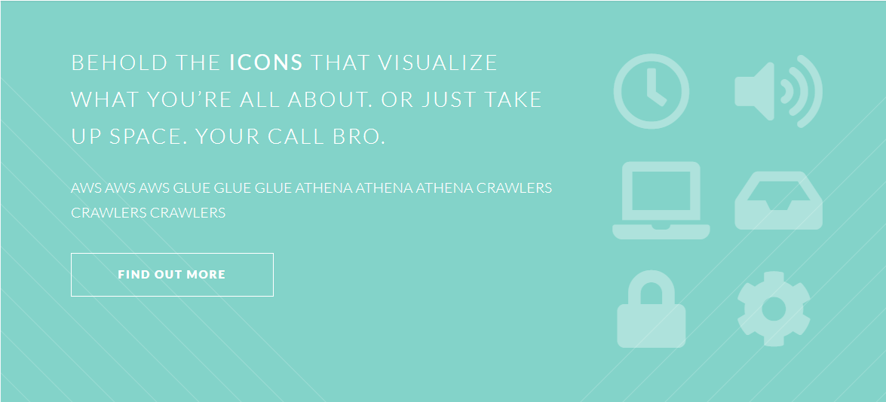

## Automate Your Data Organization for Better Insights

You know it, data drives almost every business decision out there - from small startups to global enterprises.

But it’s not just enough to have the data at hand - you also need to store, organize and make sense of the sheer amount of data that flows through your business.

Trying to handle this load manually with outdated spreadsheets is a surefire cause of headaches, not to mention errors too.

By relying on manual processes, you end up creating silos between different departments and channels, depriving your teams of useful insights.

So, why should you risk hindering important collaboration and killing valuable insights when our solution can help automate the process and keep your data organized in one place?

**>>> FIND OUT MORE <<<**

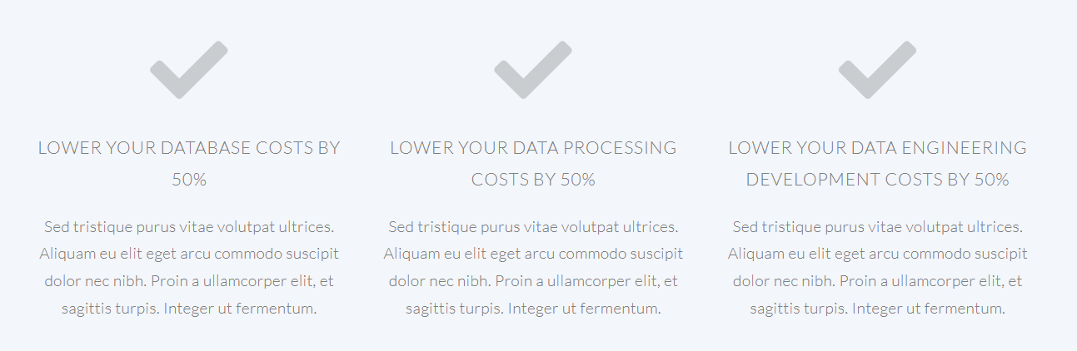

## Extract More Value From Your Data

Organizing data can be an intimidating, time-consuming and difficult task. But with our automated data organization solution, you can make tidying up your data a breeze. Not only will you have access to powerful insights that will drive better decisions, but you'll also be able to integrate our platform seamlessly with external sources like Google Analytics or Salesforce to increase the value of your data. You can trust that our software provides a single source of truth so you always have up-to-date information at your fingertips. Give yourself the gift of taking advantage of all the insights that come from organized data.

## Eliminate The Threat Of Data Silos

With data silos, you run the risk of having outdated information and a lack of collaboration. Our automated data organization platform helps to eliminate these risks by providing you with a single source of truth to quickly access all of your data in one place. This way, departments have access to the exact same information so everyone is up-to-date on the latest developments. Our platform can also be used to help provide insights for cross-team collaboration, making it easier to collaborate on projects and ensure everyone's goals are in alignment.

## Revolutionize The Way Data Is Harvested

Our automated data organization platform can help you not only organize, but also harvest and analyze data, giving you a better understanding of the needs of your customers. Once collected, you can use this information to make informed decisions about how to best optimize your services and offerings. With our powerful tools at your disposal, it’s easy to create custom reports and keep track of all the data flowing through your business.

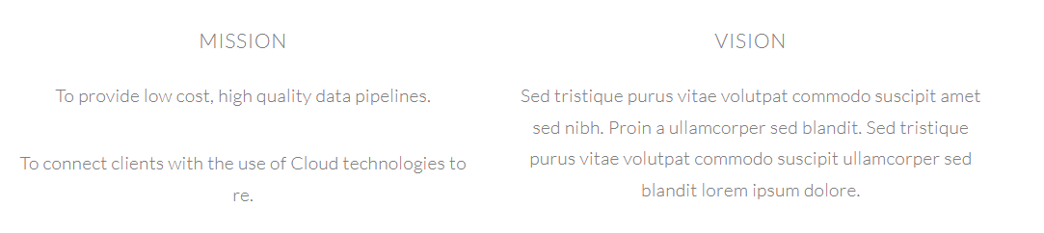

## MISSION

Our mission is straightforward: to make sure your data works for you in the most efficient and cost-effective manner possible. We strive to provide unparalleled service with each and every client we interact with, so give us a try and let us show you what quality data pipelines can do for you.

## VISION

We strive to be the industry leader in automated data organization, providing our customers with a single source of truth that makes sense of their data and drives better decisions. Our ultimate goal is to revolutionize the way businesses interact with data, giving them an edge over their competition and enabling them to extract more value from their information.

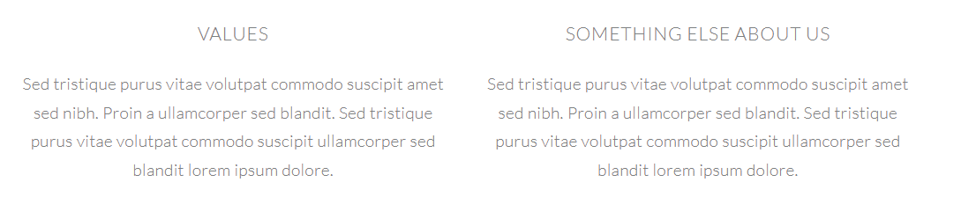

## VALUES

At our core, we value:

**Quality** – We focus on delivering high-quality results for our clients.

**Transparency** – We provide honest and open communication to make sure every customer knows exactly what they’re getting.

**Speed** – We are committed to providing fast, efficient results that set us apart from the competition.

**Innovation** – We strive for continuous improvement by leveraging the latest technologies to provide cutting-edge solutions.

**Collaboration** – We believe in working together to deliver the best possible outcomes for our clients.

**UTMOST RELIANCE**

By relying on us, you can trust that your data is organized, secure and up-to-date so you can make the most informed decisions. Contact us today to get started on your journey towards data-driven success.

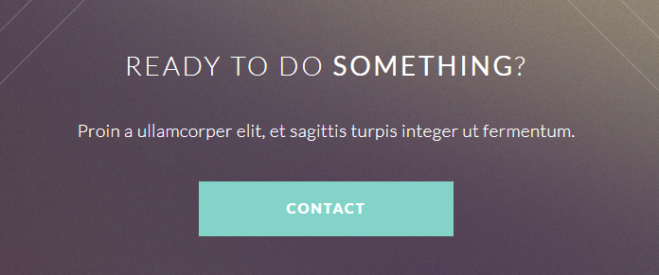

## READY TO CAUSE A SPIRAL?

Get in touch with us today and let’s start creating some meaningful insights together!